## 3.Locked Profile

In this problem, you should **create a JS functionality** that **shows** and **hides** the additional information about users.

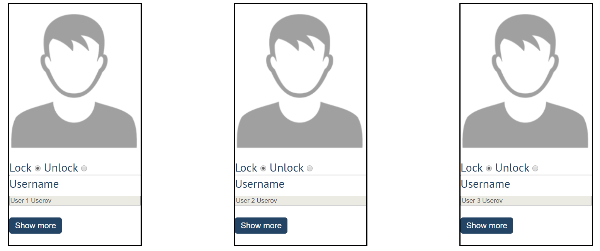

When one of the [**Show more**] **buttons** is clicked, the **hidden information** inside the div should

be shown, only if **the profile is not locked**! If the current profile is **locked,** nothing should happen.

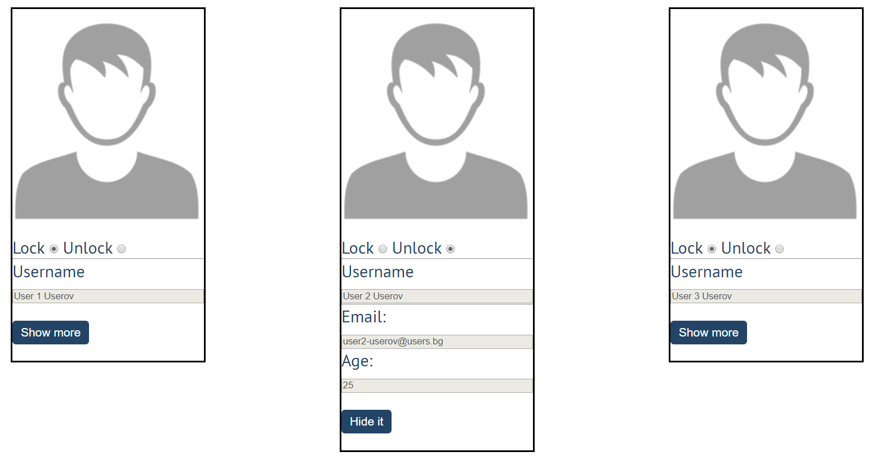

If the **hidden information is displayed** and we **lock** **the profile again**, the [**Hide it**] button should **not be working**!

Otherwise, when the profile is **unlocked** and we click on the [**Hide it**] button, the new fields must hide again.